**HRD 2103:GENERAL ECONOMIC**

**ASSIGNMENT**

**Name: AKECH DAU ATEM**

**Reg_No: SCT211-0535/2022**

## **1. Meaning of Economics**

Economics is the study of decision-making in situations of limited resources. It examines how individuals, firms, and governments allocate scarce resources to meet their endless needs and desires. The discipline is focused on solving the problem of scarcity.

## **2. Branches of Economics**

Economics is divided into two primary branches:

### **a) Microeconomics**

Microeconomics examines the behavior of individual entities such as consumers, firms, and workers. It studies how they make decisions about resource allocation, pricing, and production to achieve the most optimal outcomes.

### **b) Macroeconomics**

Macroeconomics deals with large-scale economic issues affecting entire economies. It looks at national and global economic indicators such as GDP, unemployment, and inflation, and how policies are used to stabilize and grow the economy.

## **3. Nature of Economics**

Economics is both a social and applied science. As a social science, it studies human behavior and societal responses to resource scarcity. As an applied science, it uses quantitative models and data analysis to predict outcomes and inform policy decisions, helping societies make better choices in resource allocation.

## **4. Economic Resources (Factors of Production)**

There are four main factors of production:

* **Land**: Natural resources such as minerals, forests, and water.
* **Labor**: Human physical and mental effort in production.
* **Capital**: Machinery, technology, and other tools that help in production.
* **Entrepreneurship**: Innovation and management of the other three factors to produce goods and services.

## **5. Economic Problems**

The fundamental problem in economics is scarcity, where resources are limited, but human wants are infinite. This leads to the need for choices in resource allocation, which requires societies to answer three key questions:

* What should be produced?
* How should it be produced?
* For whom should it be produced?

## **6. Principles of Economics**

Economics is based on several key principles:

* **Scarcity**: Resources are limited relative to human wants.
* **Choice**: Given scarcity, choices must be made about how to allocate resources.
* **Opportunity Cost**: The cost of the next best alternative that is forgone when a choice is made.
* **Production Possibility Frontier (PPF)**:

A graphical representation that shows the trade-offs between two goods (e.g., Product A: Wine and Product B: Cotton).

* + **Points on the curve (A, B, C)** represent efficient use of resources, meaning the economy is operating at its full potential.
  + **Point inside the curve (X)** represents inefficiency, indicating underutilization of resources.
  + **Point outside the curve (Y)** represents unattainable levels of production with the current resources.
  + The outward shift of the PPF reflects economic growth or technological improvement, allowing more production of both goods.

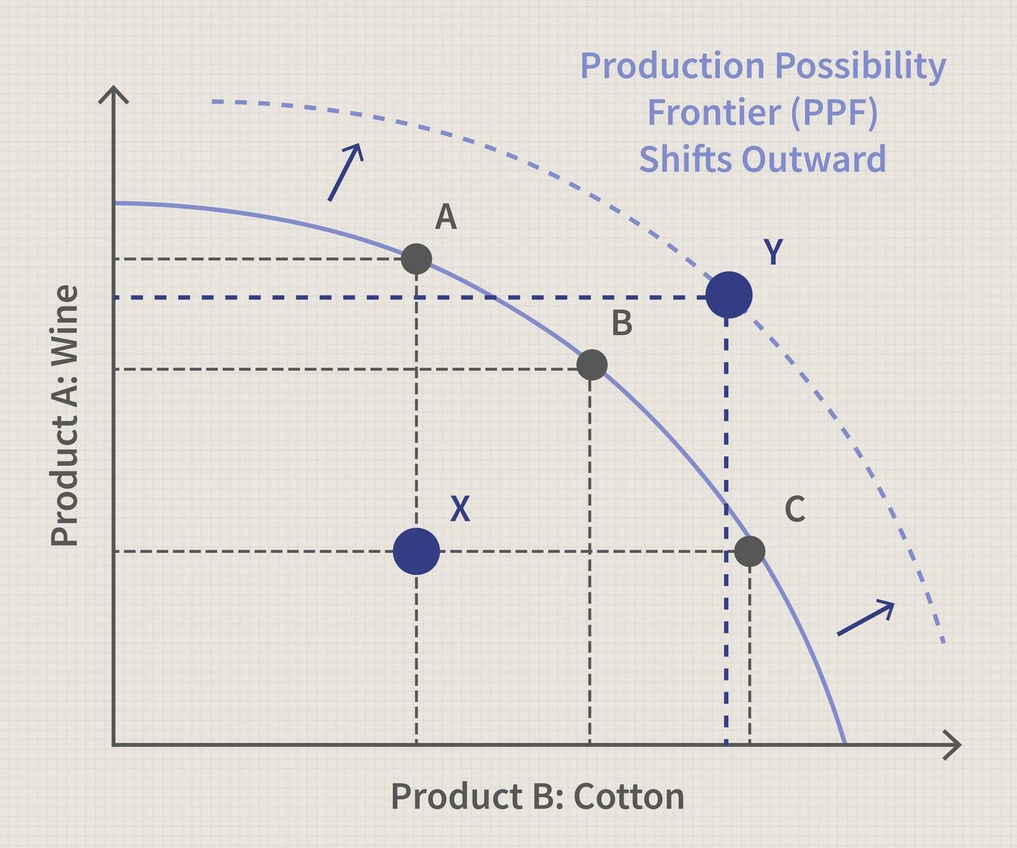

## **7. Economic Systems**

### **a) Free Market Economy**

* **Features**:
  + Private individuals and businesses own resources.
  + Prices and production are determined by supply and demand.
  + Minimal government intervention.
* **Advantages**:
  + Encourages innovation.
  + Promotes efficiency.
  + Offers consumer choice.
* **Disadvantages**:
  + Can lead to income inequality.
  + Fails to address public goods and environmental concerns.

### **b) Command/Planned Economy**

* **Features**:
  + The government controls the allocation of resources and production.
  + Central planning dictates what goods are produced and how they are distributed.
* **Advantages**:
  + Ensures equal distribution of resources.
  + Reduces unemployment.
  + Focuses on long-term social welfare.
* **Disadvantages**:
  + Lacks flexibility and innovation.
  + May result in inefficiency and does not always meet consumer needs.

### **c) Mixed Economy**

* **Features**:
  + Combines free-market principles with government intervention.
  + Both private businesses and government institutions operate in the economy.
* **Advantages**:
  + Balances competition with regulation.
  + Addresses market failures and provides a safety net for vulnerable populations.
* **Disadvantages**:
  + Excessive government intervention can lead to inefficiency and bureaucracy.